EE387 – Signal Processing

Lab03 - System Functions and Frequency Response

S.THINESH

E/15/366

**PART 1: Pole-Zero Diagrams in MATLAB.**

**Example**

clear all;

close all;

b = [1 -1]; % Numerator coefficients

a = [1 2 2]; % Demoninator coefficients

zs = roots(b); % Generetes Zeros

ps = roots(a); % Generetes poles

pzmap(ps,zs); % generates pole-zero diagram

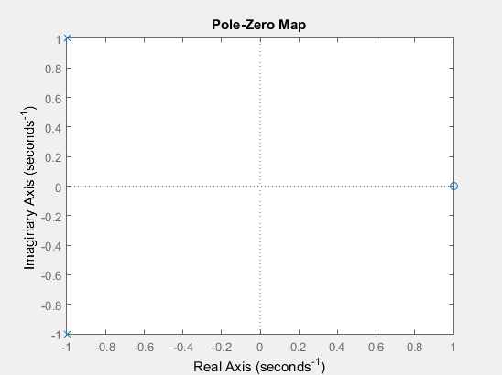

**1.**

a = [1 5];

b = [1 2 3];

z = roots(a);

p = roots(b);

pzmap(p,z);

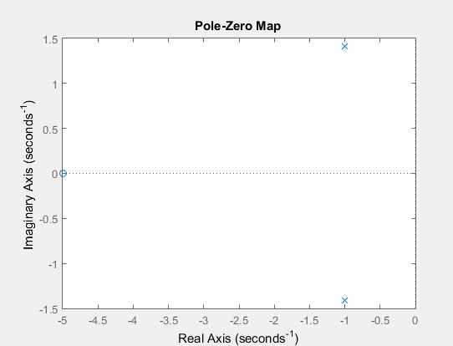

**2.**

a = [2 5 12];

b = [1 2 10];

z = roots(a);

p = roots(b);

pzmap(p,z);

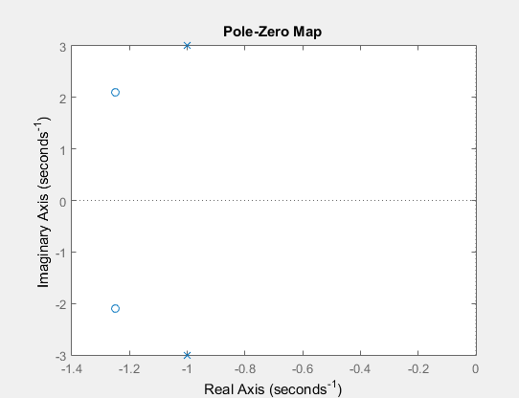

**3.**

a = [2 5 12];

b = [1 4 14 20];

z = roots(a);

p = roots(b);

pzmap(p,z);

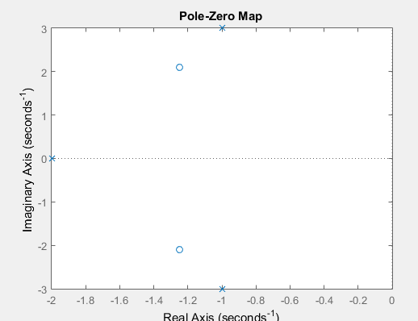

**PART 2: Frequency Response and Bode Plots in MATLAB**

a = [2 2 17];

b = [1 4 104];

omega = linspace(-20,20,200);

x = freqs(a,b,omega);

subplot(3,1,1);

plot(omega, abs(x),'r');

subplot(3,1,2)

plot(omega, angle(x),'y');

x1=tf(a,b);

subplot(3,1,3)

bode(x1,'b');

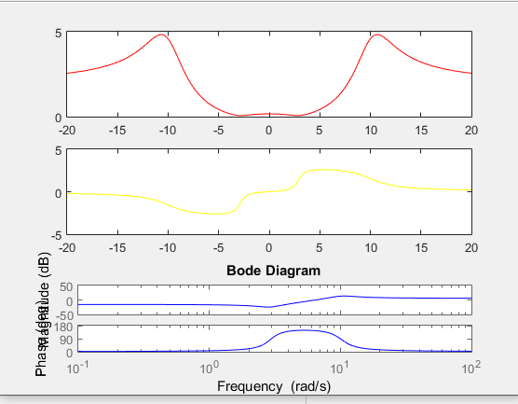

**Exercise**

**1.**

a1 = [1 5];

b1 = [1 2 3];

a2 = [2 5 12];

b2 = [1 2 10];

a3 = [2 5 12];

b3 = [1 4 14 20];

x2=tf(a1,b1);

subplot(3,1,1)

bode(x2,'r');

x3=tf(a2,b2);

subplot(3,1,2)

bode(x3,'b');

x4=tf(a3,b3);

subplot(3,1,3)

bode(x4,'g');

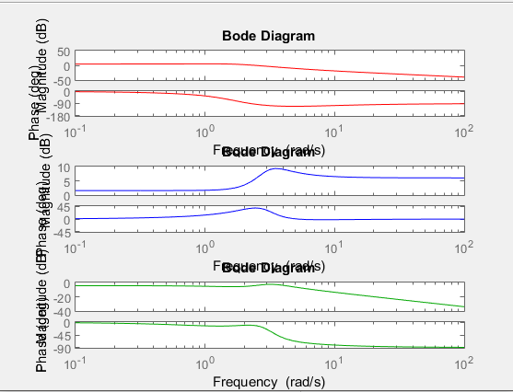

**2.**

syms s;

omega = linspace(-20,20,200);

lh1 = (s+5)./(s*s+2*s+3);

lh2 = (2*s*s+5*s+12)./(s*s+2*s+10);

lh3 = (2*s*s+5*s+12)./(s.^3+4*s*s+14*s+20);

% Registration Number = 366

w1 = 2*pi*366*1;

w2 = 2*pi*366*2;

w3 = 2*pi*366*3;

lx1 = sin(w1*omega);

lx2 = sin(w2*omega);

lx3 = sin(w3*omega);

%give signal lx1 to all the systems

y12 = ilaplace(lx1.*lh1)

y13 = ilaplace(lx1.*lh2)

y14 = ilaplace(lx1.*lh3)

%give signal lx2 to all the systems

y22 = ilaplace(lx2.*lh1)

y23 = ilaplace(lx2.*lh2)

y24 = ilaplace(lx2.*lh3)

%give signal lx3 to all the systems

y32 = ilaplace(lx3.*lh1)

y33 = ilaplace(lx3.*lh2)

y34 = ilaplace(lx3.*lh3)

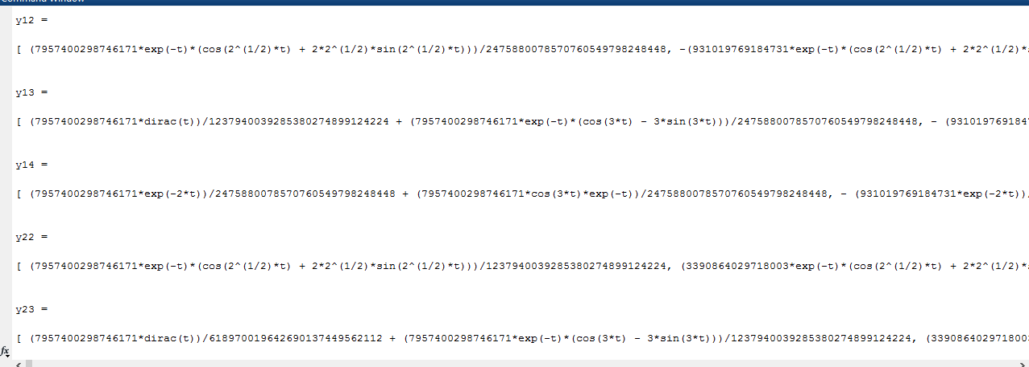

**PART 3: Surface Plots of a System Function in MATLAB**

%consider the system in part1 exercise 1help

b = [1 5];

a = [1 2 3];

omega = linspace(-20,20,200);

sigma = linspace(-5,5,200);

%system response matrix

[sigmagrid,omegagrid] = meshgrid(sigma,omega);

sgrid = sigmagrid+1i*omegagrid;

%evaluate the numerator and denominator polynomials

H1 = polyval(b,sgrid)./polyval(a,sgrid);

%surface graph of the magnitude of H(s)

mesh(sigma,omega,20*log10(abs(H1)));

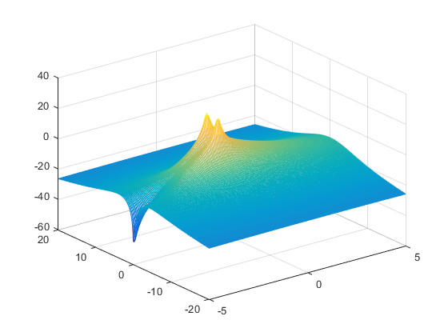

Zeros and poles are in the XY horizontal plane. Poles are same in two bode plot and the surface plot.